A universal DFT verification environment: Filling the gap between function simulation and ATE test

Rui Huang
Advanced Micro Devices, Inc., Beijing, China, 100190, Rui.Huang@amd.com
No.2, Science Institute South Rd. Haidian District, Beijing, 100190

Abstract-The DFT design is becoming more and more complex accompany with the scale increasing of SoC. How to verify DFT logic completely in simulation and supply test patterns to ATE test with highly coverage is important for post-silicon debug and yield increase. While verification methodology is evolving, innovating and entering UVM era, DFT verification need to keep in pace to leverage the advantage of UVM, therefore to increase test reusability, extendibility and function coverage etc. This paper presents a general UVM based DFT verification environment, which is usable from modular DFT verification to SoC DFT verification, and it can generate STIL test patterns for ATE test during SoC simulation. This paper also presents a method to model hierarchically networked DFT TDR in register abstract level in UVM environment to let test writers focus on test sequences not caring the details of TDR read and write.

I. Introduction
In DFT (Design For Testability) domain, the test patterns running on an ATE (Automatic Test Equipment) can be categorized into two types: scan related and non-scan related. The former can be generated using ATPG (Automatic Test Pattern Generation) tools, while the latter cannot. Like other function tests, these non-scan DFT function tests are normally created by design verification engineers using languages such as System Verilog or C++. However, ATEs need test patterns described by STIL (Standard Test Interface Language) or other test languages.
To fill the gap, there is usually a dedicated team to transfer function simulation to ATE test environment, or alternatively in-house automation flows are developed to enforce complex rules on test writing and register specification documentation, which are specific for a given environment and difficult to migrate.
This paper provides a universal and more efficient solution by introducing a UVM (Universal Verification Methodology) based DFT verification environment that naturally generates test patterns in STIL format during simulation and can be plugged into any UVM based environment. This method applies to other formats that ATEs need.
For ultra-large-scale SoC (System on Chip), IEEE 1149 protocol alone cannot satisfy DFT design requirements, so IEEE 1687 and 1500 protocols are usually adopted to enable modular and hierarchical DFT test access, leading to challenges when writing test sequences at RAL (register abstract level), as different protocol TDRs (Test Data Register) are hierarchically located in a network connected via IEEE 1687. To access a TDR one or more levels 1687 SIBs (Segment Insertion Bit) have to be set and the length of DR (Data Register) chain varies with SIB values. The author also comes up with a general way to model complex DFT test access network.

Proceed of This Paper
This paper is intended to divide into four parts. The first part is about how to build a UVM based DFT verification environment that can generate STIL test patterns innately. The second part is focus on how to lift DFT TDR to register abstract level. The third part is how to verify the generated STIL pattern is workable. The fourth part is about result discussion and conclusion.
In both of the first and second parts, the method we developed will be elaborated as follows: firstly our idea will be briefed to give a general overview, and then the detailed implementation will be explained with reference to an example.

II. UVM Based DFT Verification Environment

Idea Overview
The STIL test pattern describes test stimulus using vectors which specify pad toggle and measurement information (called STIL information hereinafter) in a time period.
A UVM test usually contains one or several sequences; the UVM sequences are finally broken down into streams of UVM sequence items (a.k.a transactions) and passed to UVM drivers. UVM drivers are in born the best supplier of STIL information.
If we restrict any pad drive and sample is controlled through a UVM driver, which enforces no direct pad connection in test bench, collect all STIL information from drivers and then write them out according to the time stamp of STIL information, we can get complete test vectors of a certain UVM test after simulation finish.
So we divide the pads of a SoC as following types for DFT functional simulation:
- IEEE 1149.1 compliance on-chip TAP (Test Access Port). Hereinafter it’s simply called JTAG (Joint Test Action Group) interface as show in Table I, which is the most significant interface for DFT design. Please be noted that in Table 1, read_not_write signal is not included in IEEE 1149.1, it’s an internal signal used only in this environment, for more description please refer to Section C.5.
- Clock pads, which are clocks need toggle in DFT functional simulation. Please see Section D for more description.
- Reset pads. All the reset related pads are categorized as this type
- Other pads. Except for type 1-3 mentioned above, the rest pads are categorized as one type. These pads may need have initial value or be toggled once in a while in simulation. Please see Section E for more description.
In Fig. 1, jtag_driver, pad_driver, clock_driver and reset_driver corresponds to above pad types from 1 to 4. The STIL generator collects STIL information from these drivers and writes them to a STIL pattern file.

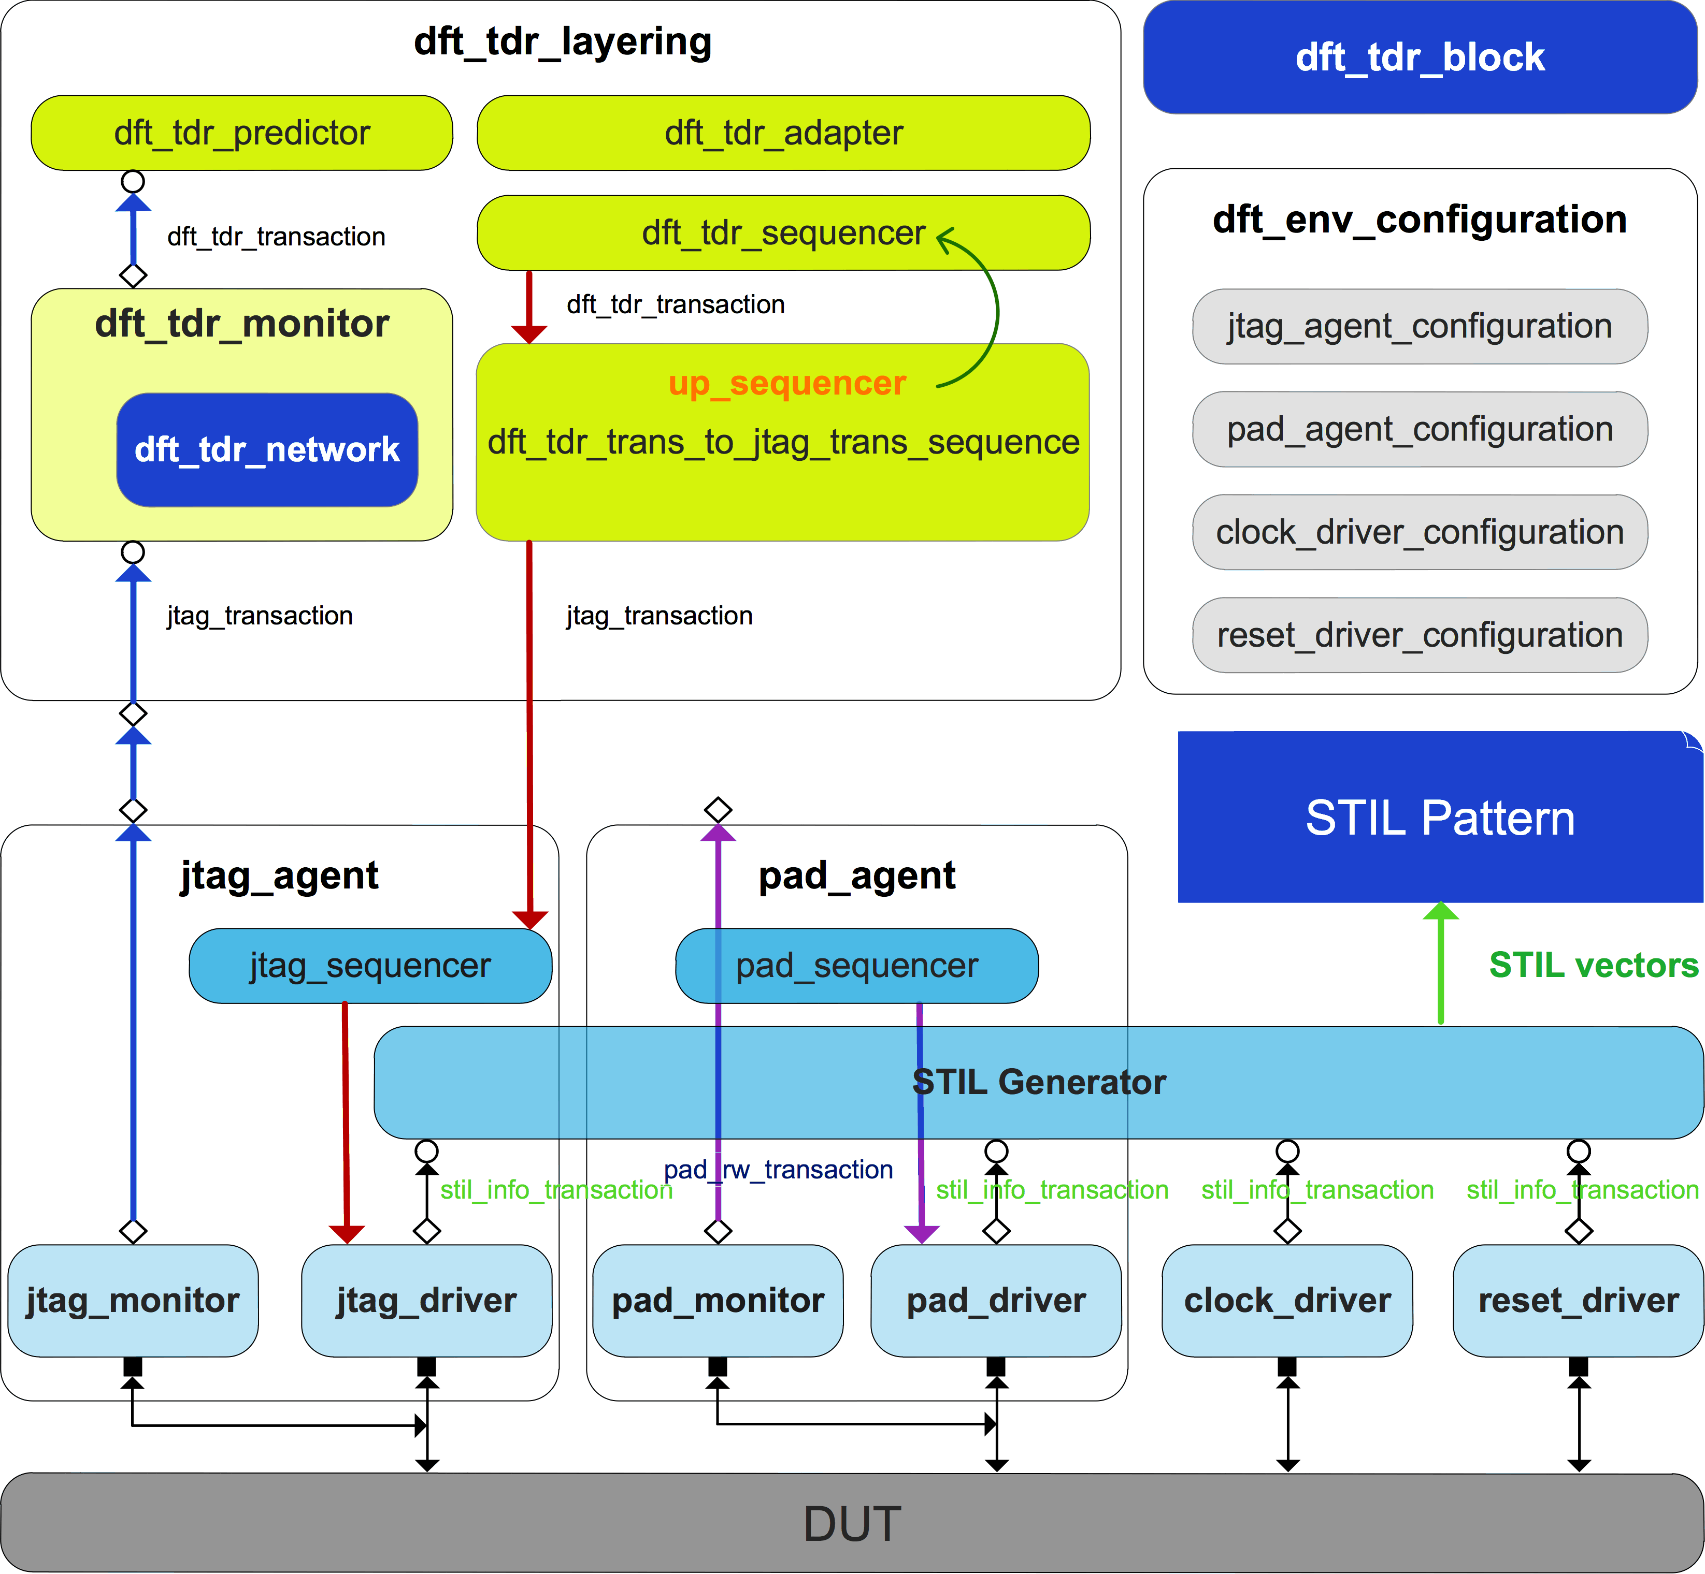

Figure 1. UVM based DFT verification environment.

jtag_agent Implementation
In Fig. 2, jtag_agent is composed of jtag_sequencer, jtag_monitor and jtag_driver, configured through jtag_agent_configuration.

jtag_agent_configuration Class
Fig. 3 shows properties and an important function of jtag_configuration class.
jtag_vi is virtual JTAG interface.
reg_block is TDR register model in RAL.
gen_stil_file is configuration knob to turn on STIL pattern generation during simulation.
stil_file_name is desired STIL pattern file name.
pad_name array stores JTAG interface package name of a SoC and pad_dir array indicate pads direction. STIL pattern files need this information to describe stimuli vectors.
DFT test must call pad_info_init function before UVM main_phase objection and store it in configuration database for drivers and STIL generator fetch.

Table I
jtag Interface Definition
JTAG Interface
Pad Direction | Pad Name
input | TCK
input | TMS
input | TRST_L
input | TDI
output | TDO
input | read_not_write

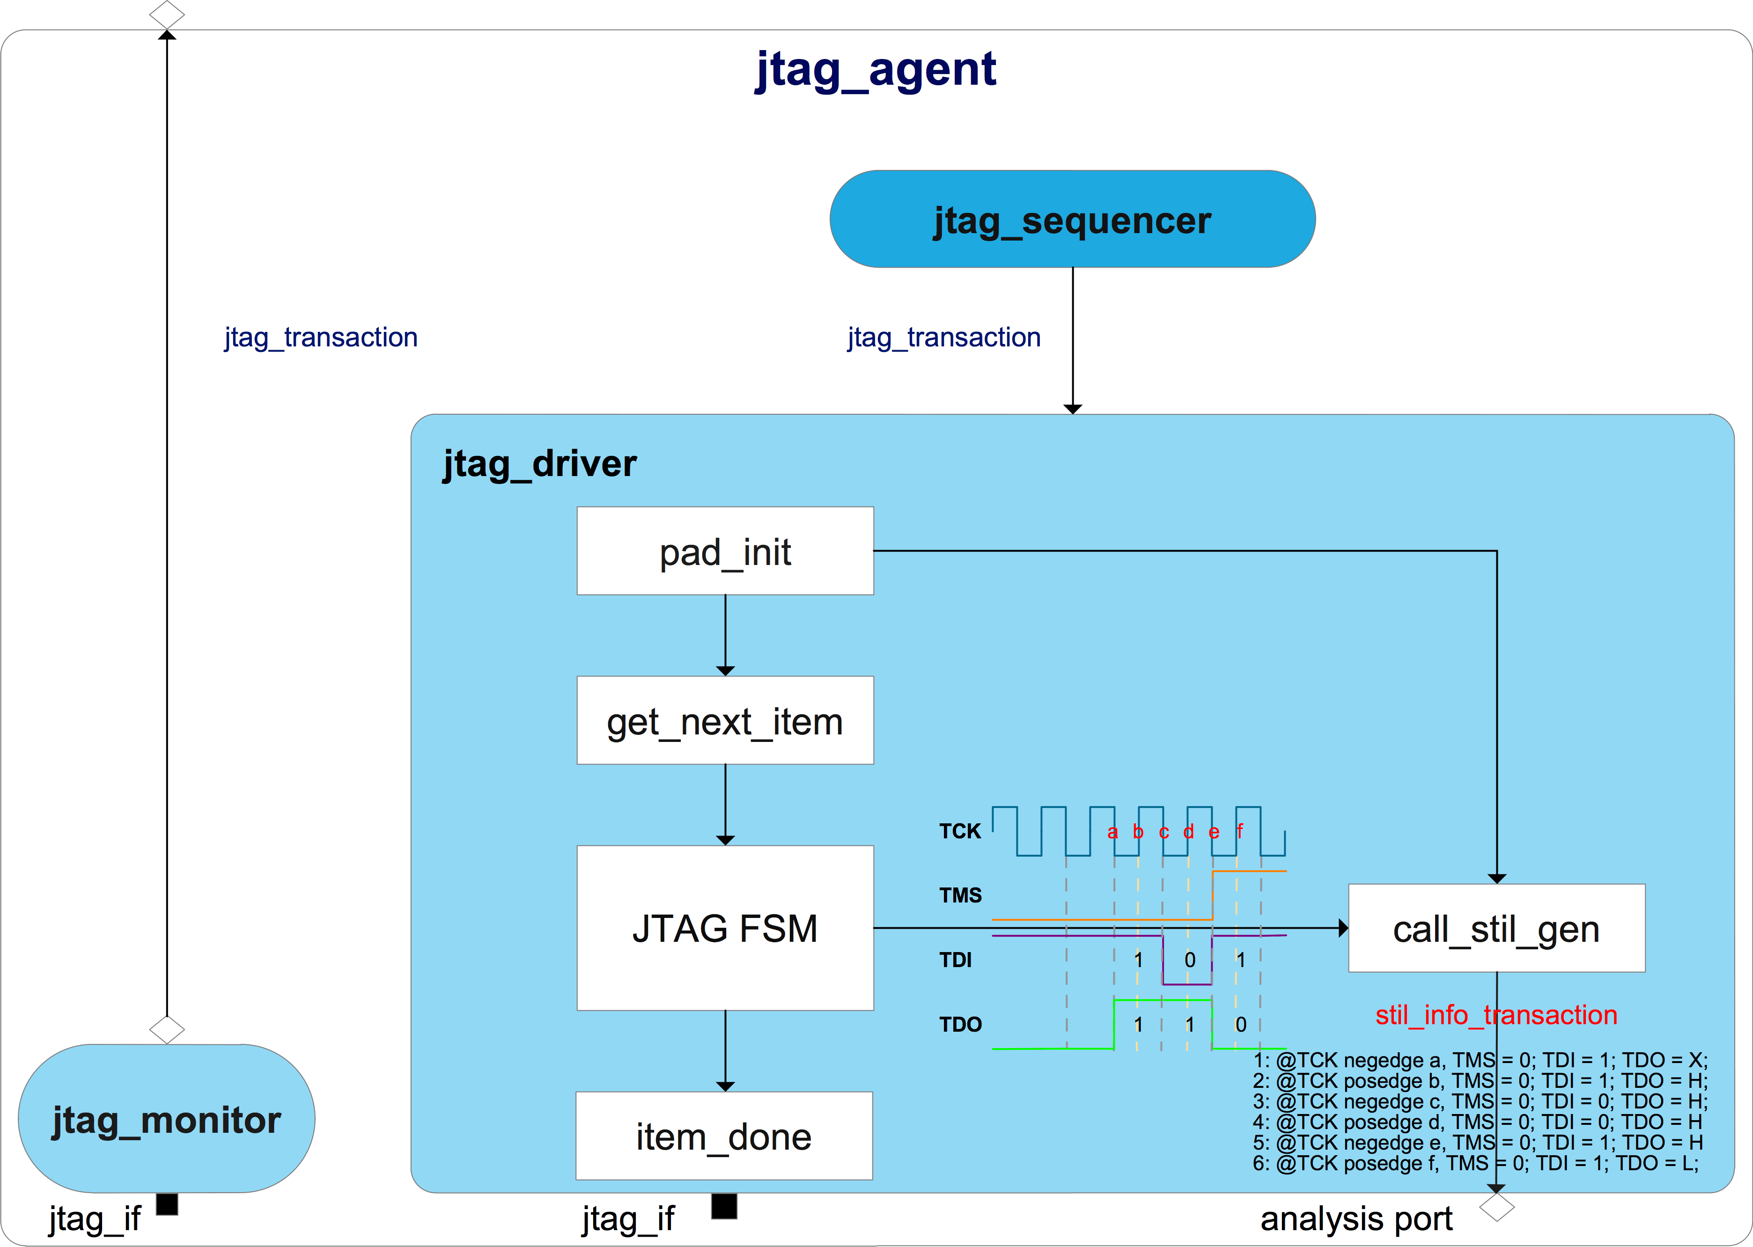
Figure 2. JTAG agent

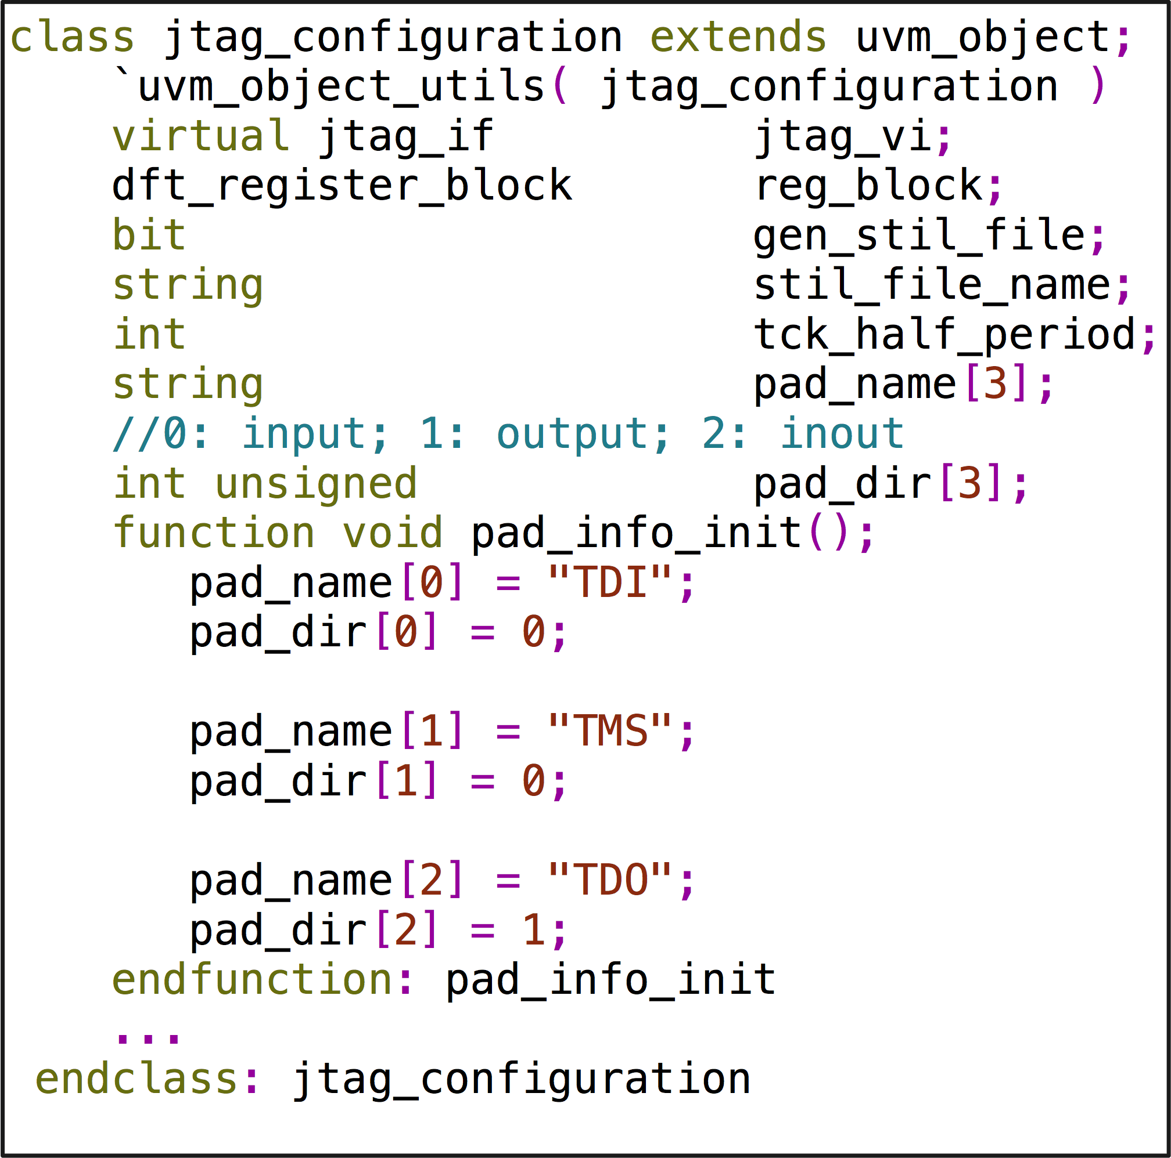
Figure 3. jtag_configuration properties and pad_info_int () method

jtag_transaction Class
Fig. 4 shows properties of jtag_transaction class.
o_ir is a dynamic array to store instruction operation code (a.k.a OPCODE) sending to DUT JTAG 1149.1 FSM Instruction Register (IR) and o_ir_length is its size.
o_dr is a dynamic array to store data sending to DUT’s IEEE 1149.1 compliance FSM Data Register (DR) and o_dr_length is its size.
tdo_dr_queue, tdo_ir_queue, tdi_dr_queue and tdi_ir_queue store data during shift IR or DR state monitoring by jtag_monitor.
chk_ir_tdo and chk_dr_tdo are flags to indicate jtag_driver whether to check TDO cycle by cycle during shift IR or DR state.
exp_tdo_dr_queue is golden data expecting DUT output during shift DR state, which is used by driver to check TDO data on the fly.
exp_tdo_dr_mask_queue indicates which bit in exp_tdo_dr_queue that we don’t care.

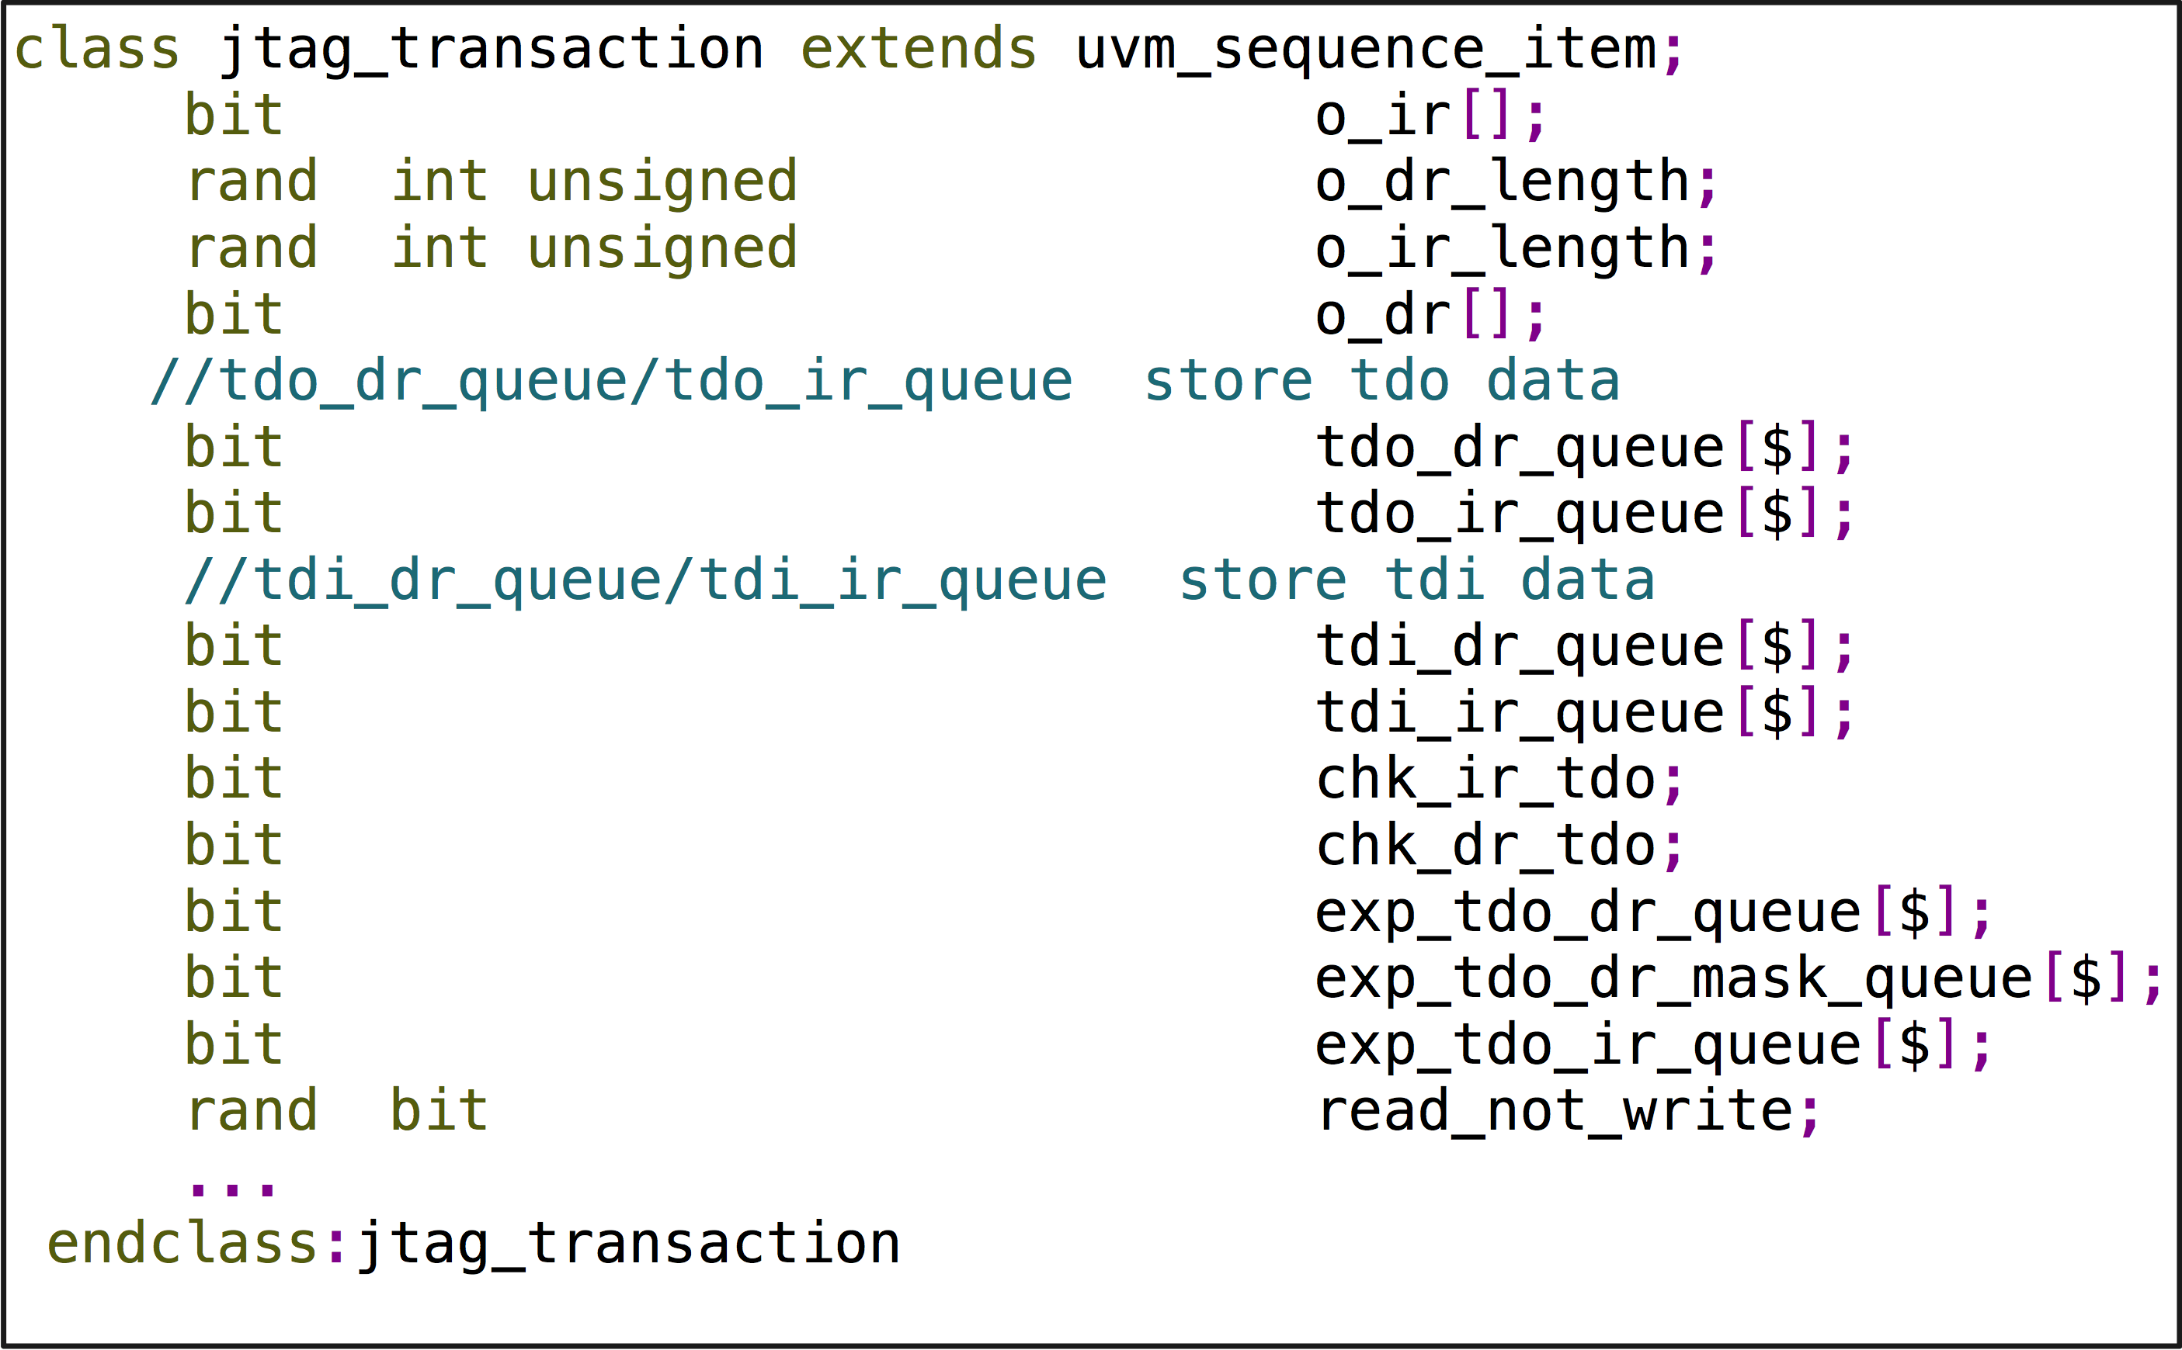
Figure 4. jtag_transaction properties

exp_tdo_ir_queue is golden data expecting DUT output during shift IR state, which is used by driver to check TDO data on the fly.
read_not_write is flag indicating jtag_monitor whether it’s a read or write operation for current transaction. Please see Section C.5 for more details.

JTAG interface
This paper categorize pads of a SoC into 4 types which are driven by different drivers, so the JTAG interface showing in Table 1 is driven by clock driver, reset driver and JTAG driver as show in Fig.5.
Fig. 6 is jtag_if definition that does not contain all signals showing in Table I because of the categorization of pads. Others signals definition are included in clock_if and reset_if.

jtag_driver Class
IEEE 1149.1 protocol is implemented in jtag_driver, which fetches every jtag_transaction sequence item from jtag_sequencer, toggles the JTAG interface’s TDI and TMS and samples TDO if chk_ir_tdo or chk_dr_tdo flag is on exp_tdo_dr_queue and exp_tdo_ir_queue store the expected golden value, which also will be used as the golden measure information for TDO in a STIL pattern.
If the gen_stil_file knob is on, jtag_driver not only need to toggle and sample pads but also need convert the toggle and sample information to STIL information (handle by call_stil_gen () method), and then send to STIL generator through an analysis port, which is an object of uvm_analysis_port class specialized with stil_info_transaction type.
In Fig. 2, let us suppose JTAG driver’s FSM is in shift DR state and is going to shift 3 bits 101 to DUT and sample TDO data during shift operation. The golden TDO data is 3 bits 110.
At TCK negative edge a, JTAG driver keeps TSM low to let DUT’s FSM stay in shift DR state and drives TDI high to send out the first bit out. call_stil_gen () method converts this information as show in line 1.
At TCK positive edge b, JTAG driver samples TDO and compares it with golden value, which is 1 bit 1. call_stil_gen () method converts this information as show in line 2.
At TCK negative edge c, JTAG driver keeps TSM low to let DUT’s FSM stay in shift DR state and drives TDI low to send out the second bit out. call_stil_gen () method converts this information as show in line 3.
At TCK positive edge d, JTAG driver samples TDO and compare it with golden value which is 1 bit 1. call_stil_gen () method converts this information as show in line 4.

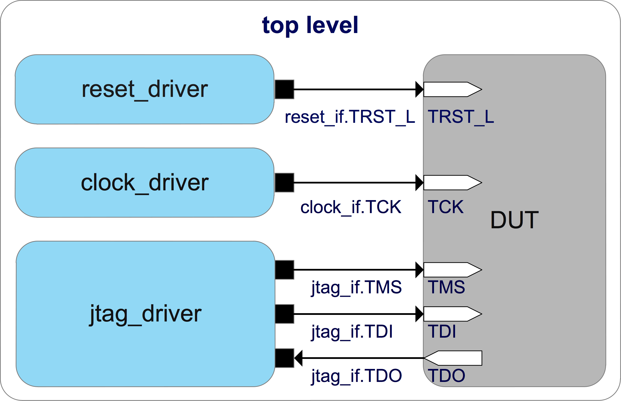
Figure 5. JTAG interface toplevel connection

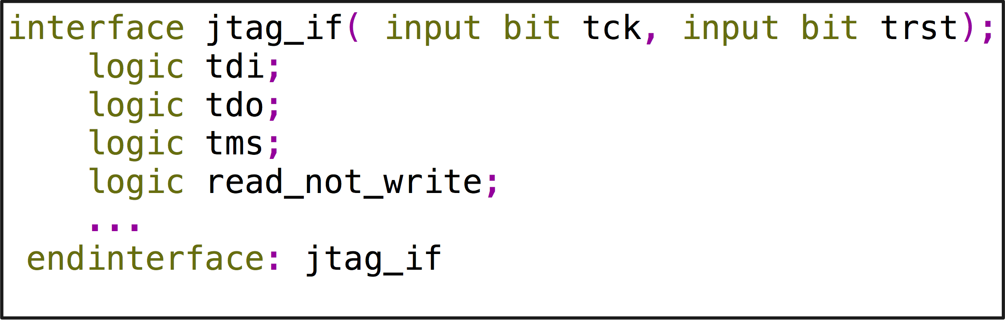
Figure 6. jtag_if properties definition
At TCK negative edge e, JTAG driver drives TSM low to let DUT’s FSM go to exit1 DR state and drives TDI high to send out the last bit out. call_stil_gen () method converts this information as show in line 5.
At TCK positive edge f, JTAG driver samples TDO and compare it with golden value which is 1 bit 0. call_stil_gen () method converts this information as show in line 6.

jtag_monitor Class
There is a signal called read_not_write defined in JTAG interface showing in Table I, which only used by jtag_monitor to indicate whether current transaction is a write operation or read operation.
JTAG interface is a serial bus, while shifting TDI to a register, data stored in it is being shift out on TDO, so there is not a really so called write or read operation.
Here define write operation and read operation in concept for register abstract level convenience.
Read operation: data being shift in a register is same as the data stored in it.
Write operation: data being shift in a register is different with the data stored in it.
jtag_monitor monitors JTAG interface activity, sampling TDI or TDO according to read_not_write signal, composing jtag_transaction sequence items and then passing them to dft_tdr_laying as show in blue arrows of Figure 1.

clock_driver Implementation
Fig. 7 is an example of how to toggle clocks in this DFT verification environment.
Suppose a DUT has two PLL reference clocks and a bypass clock need to active during simulation, which are PLL1_REF, PLL2_REF and BYPASS_CLK as show in Fig. 7.
clock_gen module in top level takes charge of these three clocks’ toggle. TCK of JTAG interface is generated by clock_driver.
If gen_stil_file knob is on, clock_driver need pass TCK toggle information to call_stil_gen () method at the same time it drives TCK, and call_stil_gen need use TCK toggle information as all active clocks’ toggle information and pass STIL information to STIL generator.
Why do this? Does this imply all clocks run on a same frequency as TCK for ATE test?
For ATE test, PLL1_REF, PLL2_REF and BYPASS_CLK toggle information in STIL pattern can be regarded as a placeholder to let post silicon engineers aware these three clocks are reference clocks, so that they will not use the toggle information described in STIL pattern to driver reference clocks, but use clocks supplied by ATE with desired frequency.

pad_agent Implementation
The pad type 4 defined in Section B, can be sub grouped according to their function or interface protocol. Take memory pads, GPIO pads and scan control pads as examples, each of them could be put in a separate sub group.
Design pad interface and pad_rw_transaction as show in Fig. 8 and Fig. 9.
Fig. 8 displays all properties of pad_rw_transaction class.
grp_num is used to indicate pad_dirver which group of pads to drive.
in_data_queue stores data being driving by pad_driver.
out_data_queue stores data being sampling by pad_driver.

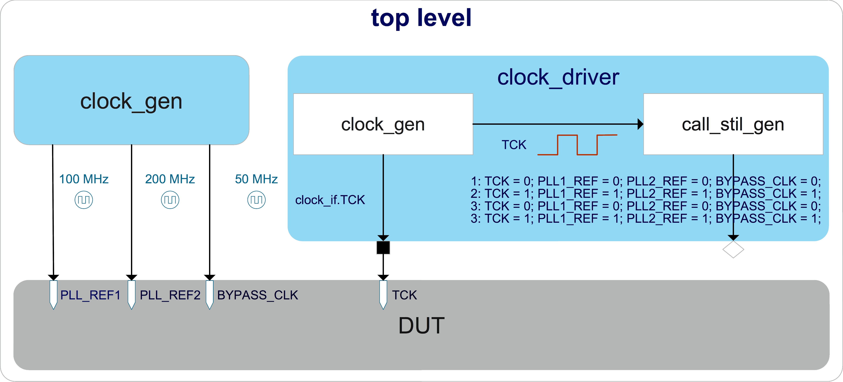
Figure 7. Clocks toplevel connection

inout_data_queue stores data being driving or sampling by pad_driver. An unknown bit in the queue indicates pad_driver the corresponding pad is in output mode and it will write the sampled value into the same location.
exp_out_data_queue and exp_inout_data_queue stores golden value to let pad_driver check on the fly and also the information for STIL pattern to measure pad value during a time period converting by call_stil_gen function.
Please be noted these queue types should be logic instead of bit to store four state values.
In Fig. 9, pad_init () method will initialize all groups pads in turn at the beginning of run_phase task, and call_stil_gen () method will convert this information to STIL information and write to STIL generation through the analysis port.

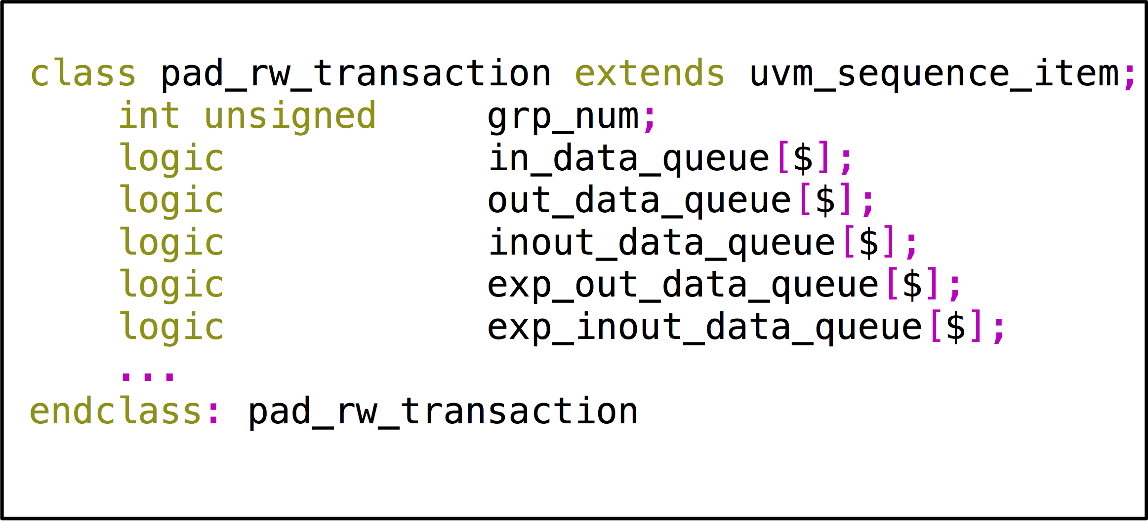
Figure 8. pad_rw_transaction properties definition

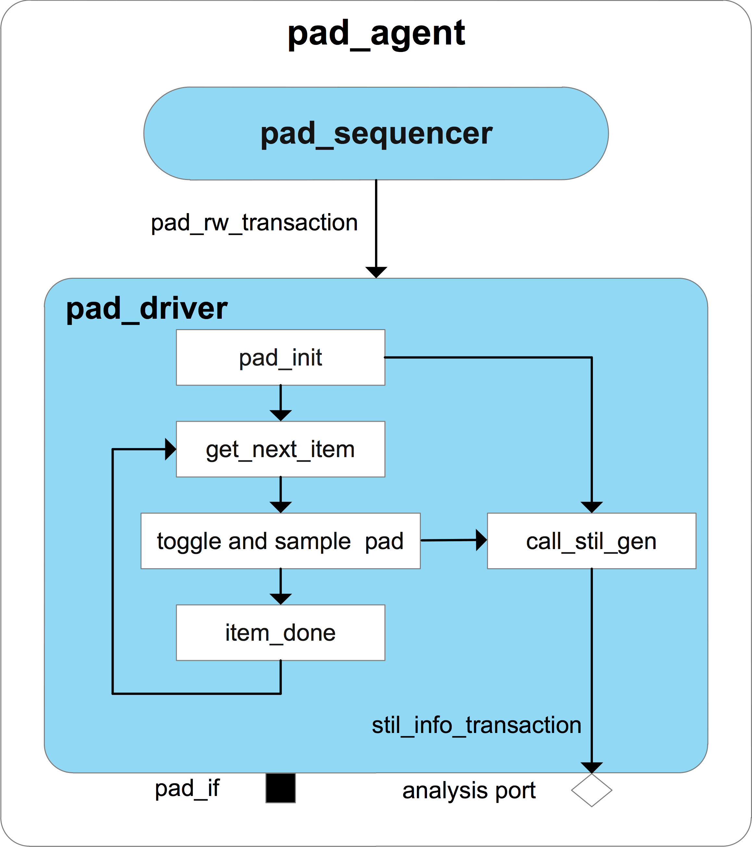
Figure 9. pad_agent

pad_agent_configuration Class
Fig. 10 is an example of pad_configuration class, which has two sub groups of pad.
UVM test need initialize every group’s package name by calling pad_info_init () method before main phase objection and store it in configuration database for pad_driver and STIL generator fetch.

reset_driver Class
In Fig. 11, reset_driver drives all resets signals defined in reset interface.

stil_generator Class
The stil_generator, which extends from uvm_subscriber class specialized with stil_info_transaction type, has four analysis exports to connect with clock_driver, reset_driver, pad_driver and jtag_driver’s analysis port separately. Since uvm_subscriber class has only one built-in analysis export, the uvm_analysis_imp_decl macro need to be used to declare analysis imp export and its associated write () method for the rest analysis export [1].

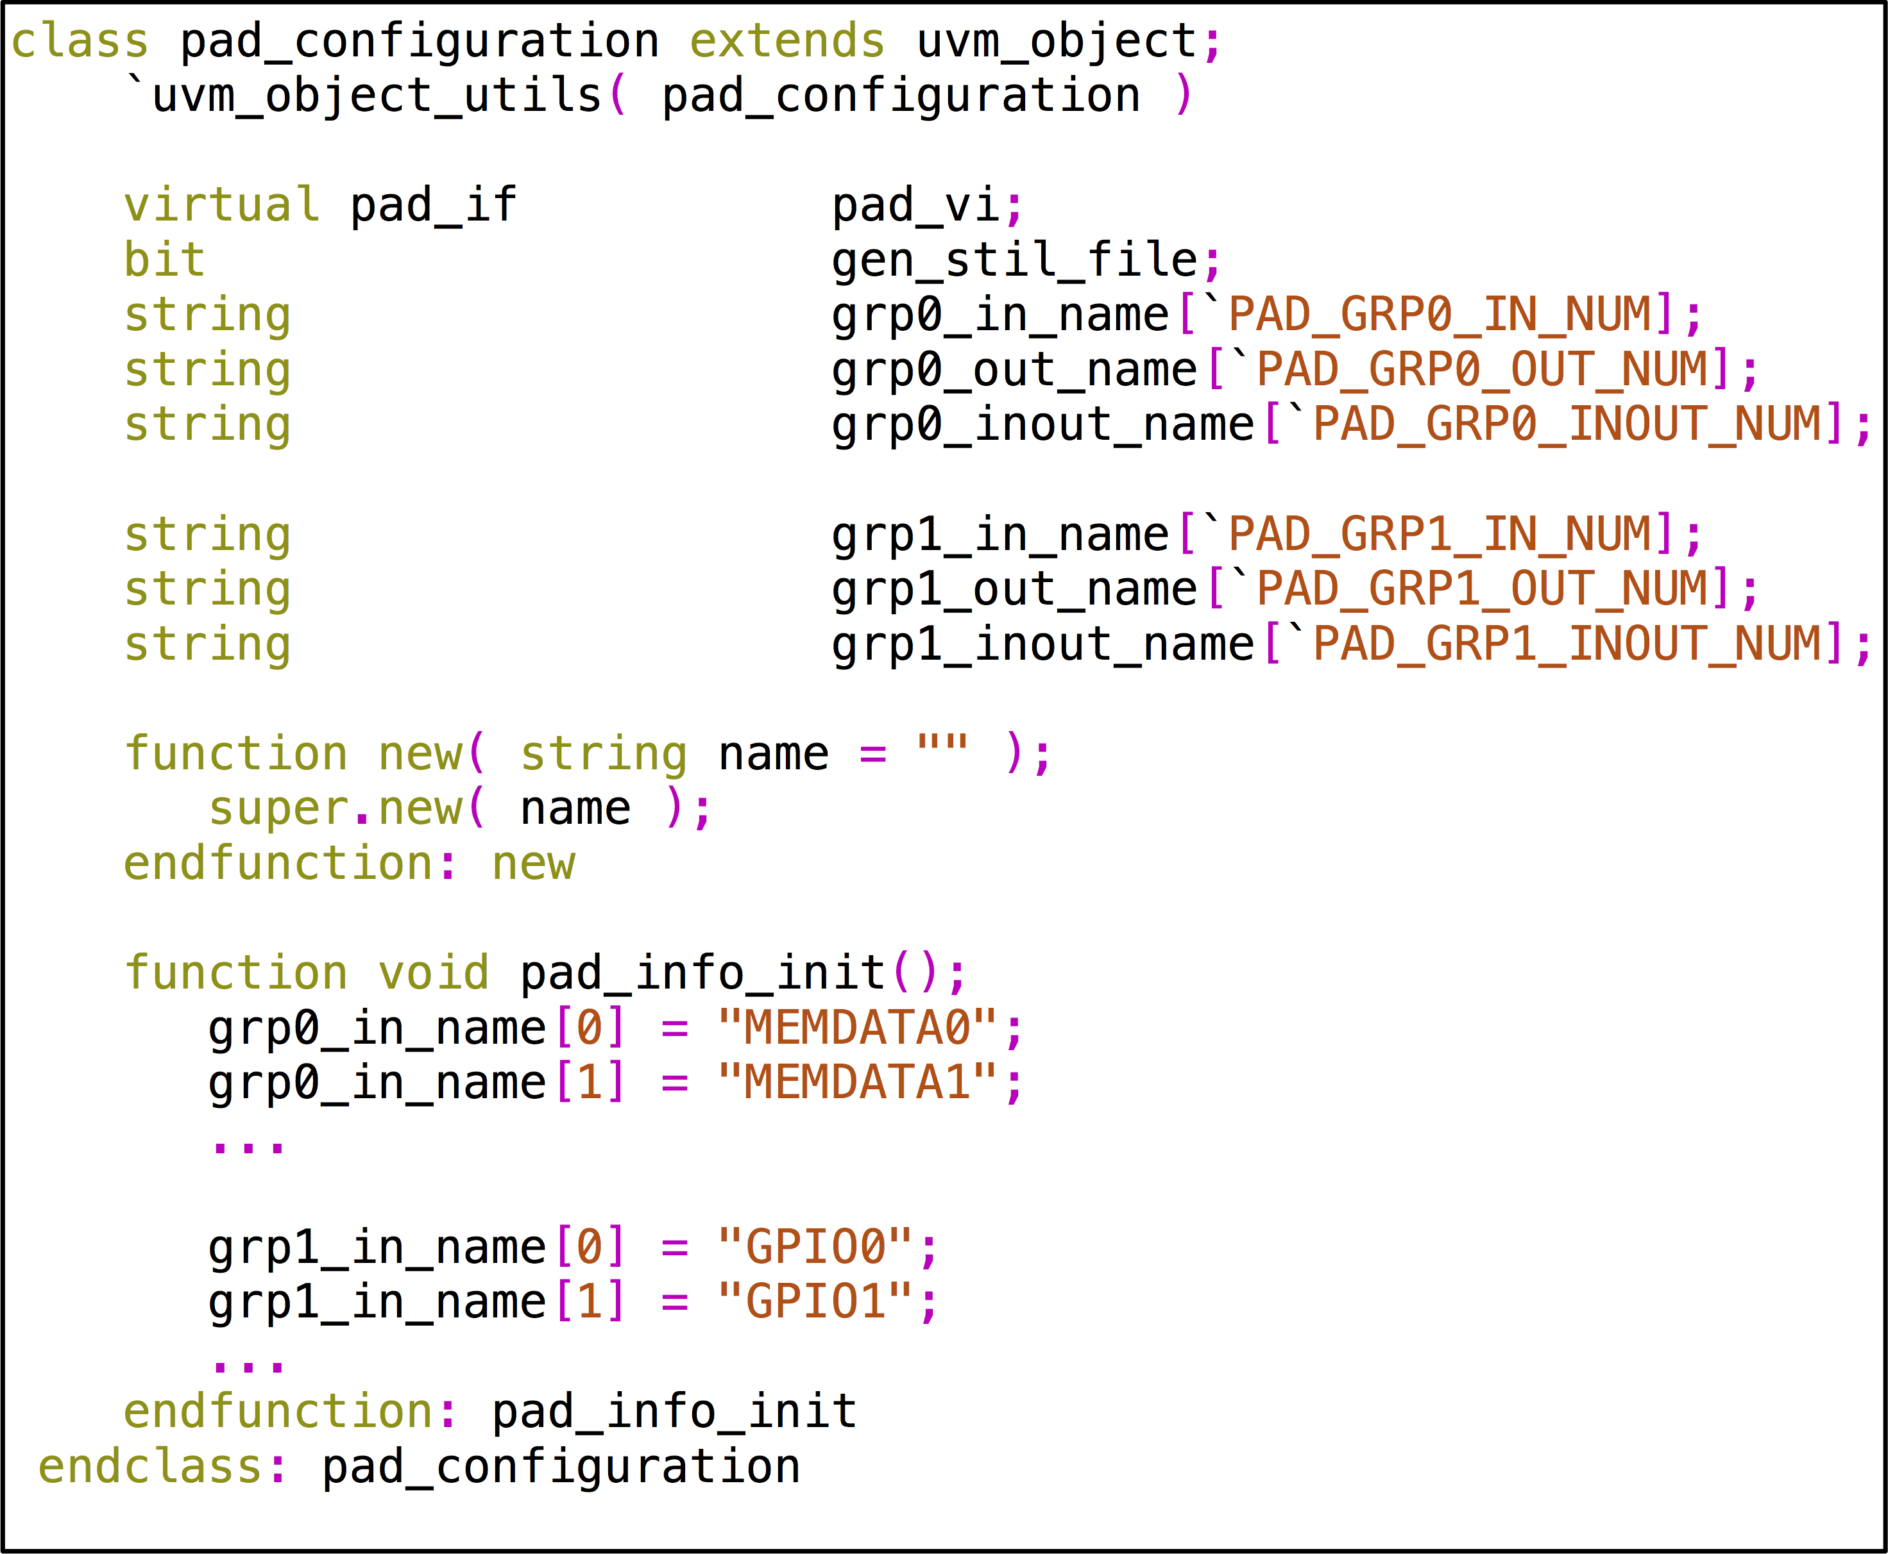
Figure 10. pad_configuration properties definition example

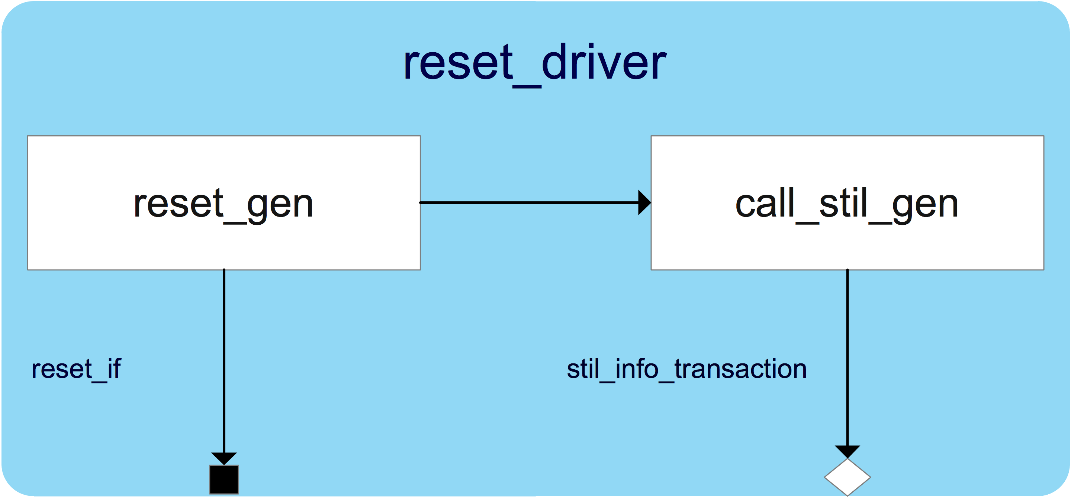
Figure 11. reset_driver
stil_info_transaction is defined in Figure 12. stil_info is pads toggle and measure information and comment info is comment going to be printed out with the stil_info.
In Figure 13, each driver’s analysis port has its corresponding write () method, a semaphore which has only one key and a group of Ping-Pong buffer which has two variables called ping_data_rdy and pong_data_rdy to indicate Ping-Pong buffer status.
The stil_info_transaction written through a driver’s analysis port is stored in a Ping-Pong buffer group, each buffer stores one stil_info_transaction.

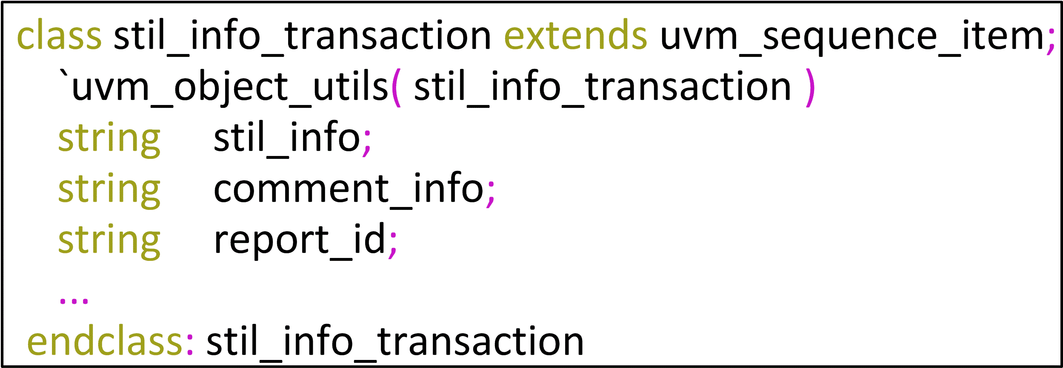
Figure 12. stil_info_transaction

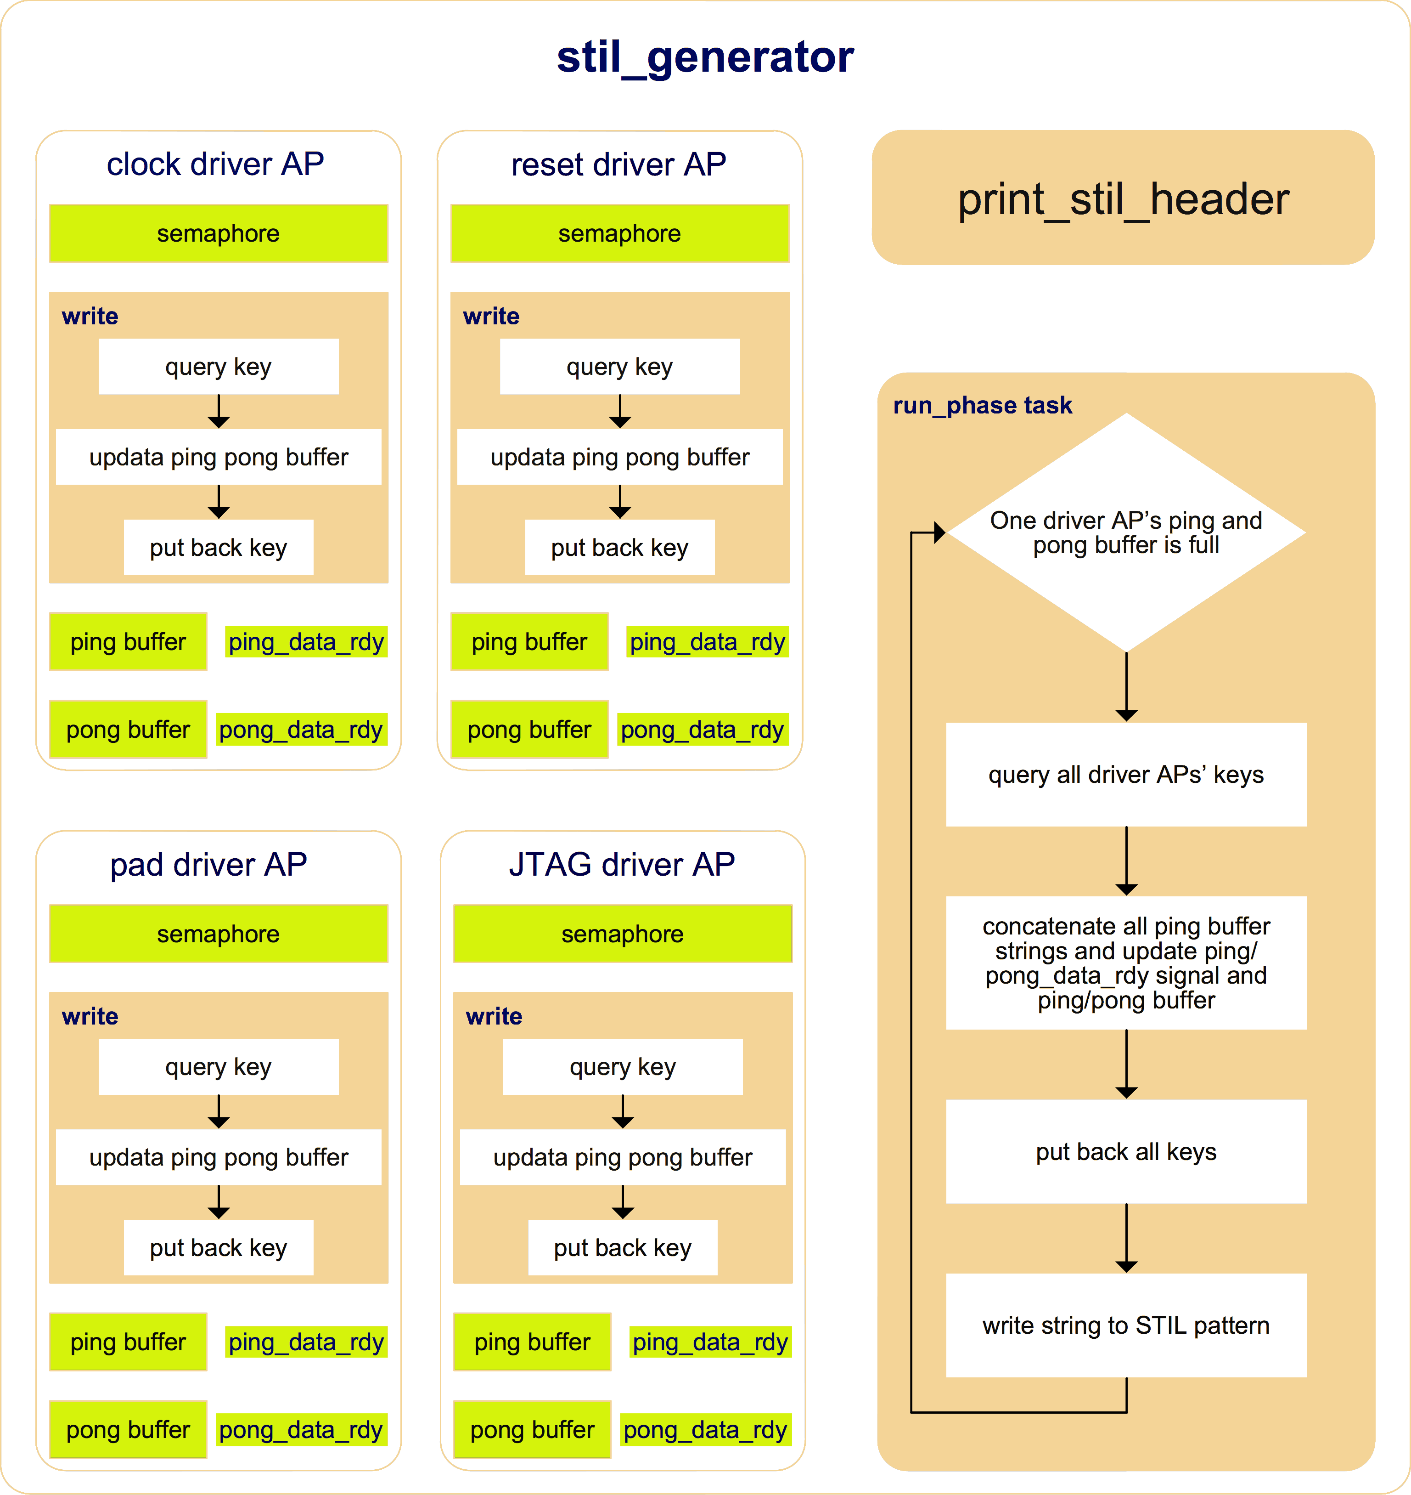
Figure 13. STIL generator
The stil_generator need collect all stil_info_transaction coming from a same simulation time slot, concatenate stil_info of every stil_info_transaction and write them out as a single test vector. To make sure stil_generator does not miss any stil_info_transaction from a same time slot, it need to suspend the run task in stil_generator until all others run task finish. However, in UVM all uvm_component run tasks are executed in parallel and stil_generator itself is an uvm_component, there is not an easy way to schedule the simulation events in stil_generator run task to execute until all drivers’ run task simulation events finish.
To resolve this, a group of Ping-Pong buffer is introduced. The write () method always writes ping buffer first and then pong buffer, because ping data and pong data come at different simulation time slot, once a group of Ping-Pong buffer is full, which indicates the simulation has already moved forward, it’s the right time to collect all ping buffer data and write them out.
The run_phase task as show in Figure 13 always check if a driver’s Ping-Pong buffer is full. If it’s true, it will query each key of the semaphore belong to corresponding driver, once get all the keys, fetches all ping buffer data, update Ping-Pong buffer (if both ping and pong buffer is empty, do noting; if ping buffer is full and pong buffer is empty, clear ping_data_rdy; if both ping and pong buffer is full, copy pong buffer data to ping buffer and clear pong_data_rdy.) and put back all keys and write a test vector to STIL pattern.

III. DFT TDR Abstraction

Idea Overview
For ultra-large-scale SoC, usually there is a group of TDRs, which are either IEEE 1500 or IEEE 1149.1 compliance, being used to configure the DFT design of a tile or a large design block. The TDR groups among different tiles are chained together using IEEE 1687 protocol. Figure 14 is an example of DFT TDR access network.
In order to hide the complex operation of accessing a TDR hierarchically located in the network, it necessary to level up TDR access in RAL.
Method of modelling DFT TDR in UVM based environment is rarely seen.
For none-UVM based environment, the normal way is to define a base class according to its protocol (for example, define an IEEE1500 TDR base class and an IEEE 1149 TDR base class) and wrap a TDR access operation inside its extension. When DFT access network changes, the wrapped access operation has to update accordingly. This is usually a time consuming work.
This paper presents a neat and easy maintain way to abstract TDR in UVM based environment as show in Fig. 15.

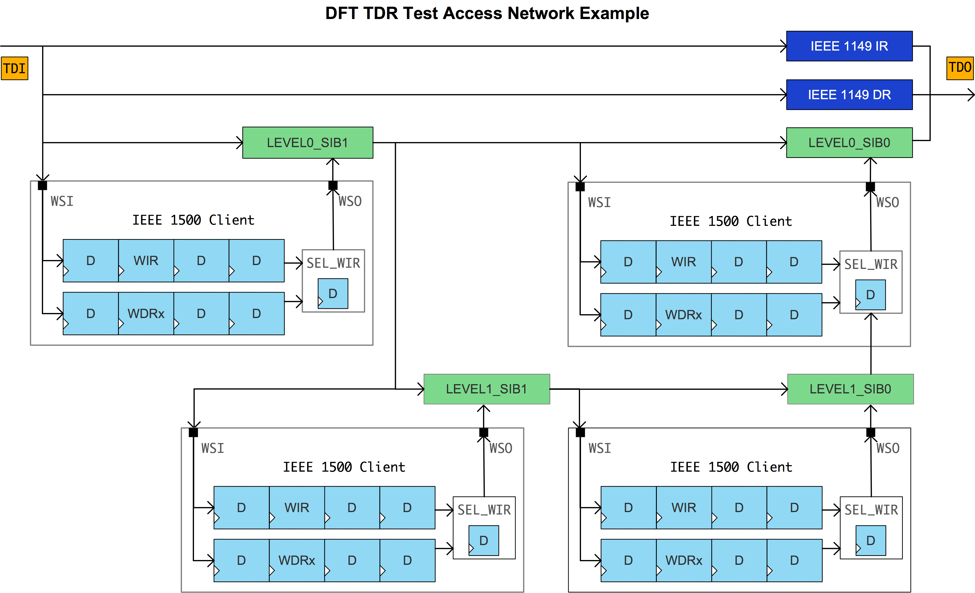
Figure 14. DFT TDR access network example

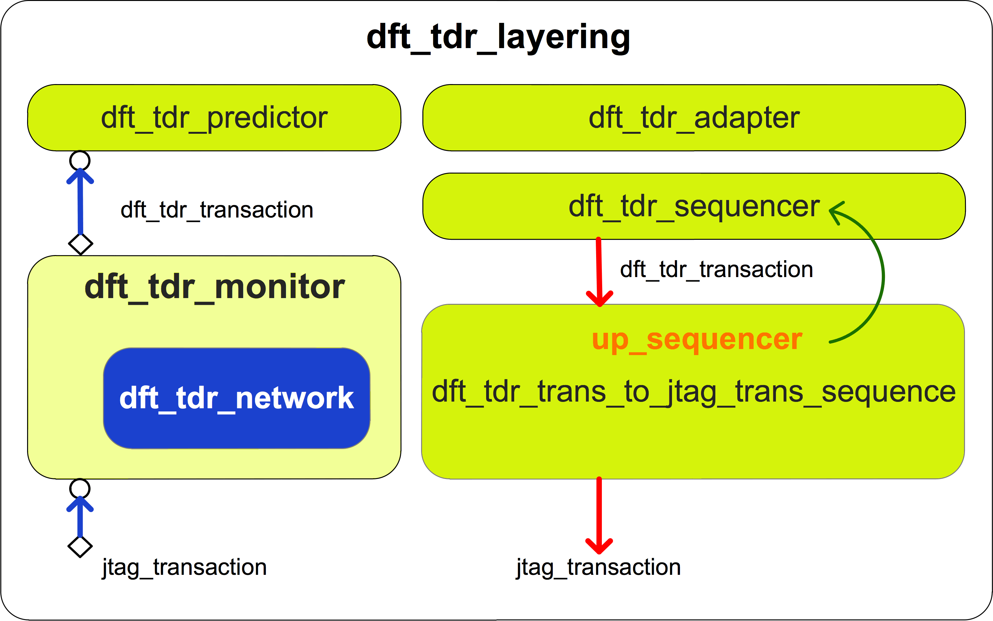
Figure 15. dft_tdr_layering

We can encode a TDR’s location information into its address showing in Figure 16 and model an equivalent TDR access network named as dft_tdr_network in dft_tdr_monitor.
In Figure 1, the reg2bus direction is shown in red lines, where dft_tdr_trans_to_jtag_trans_sequence fetches dft_tdr_transactions, unpacks address, decodes SIB code, and then generates jtag_transactions to jtag_sequencer [2]. For the bus2reg direction shown in blue lines, dft_tdr_network maintains network status using jtag_transactions from jtag_monitor. When sib_node values hit SIB code in dft_tdr_block, dft_tdr_monitor writes a dft_tdr_transaction to dft_tdr_predictor.
In this way, the TDR class definition is very neat, only need declare each bit field. Figure 18 is an example of a TDR class. When TDR access network changes, we only need to update dft_tdr_network and dft_tdr_trans_to_jtag_trans_sequence, while all TDR class definition don’t need any update which can save a lot of test environment setup time.

DFT TDR Access Network Modelling
In DFT TDR access network, a SIB bit and a TDR bit can be modelled as Figure 17.
out_update () method is to model the active clock edge triggering the shift register bit during shift operation and value_update () method is to model the active clock edge triggering the update register bit during update operation.
dft_tdr_network using sib_node and reg_node to construct an equivalent network as DUT.
In Figure 14, only need to model each 1500 client’s IR and a WDR which length is dynamic, which can calculate from jtag_transaction coming from jtag_monitor and current network chain length. It need not to actually model every TDR, because each time only a TDR can be configured in a 1500 client.

DFT TDR Class Definition
DFT TDR class definition is similar as other function registers, which extend from uvm_reg class. A bypass TDR which has only one-bit field is defined as Figure 18.

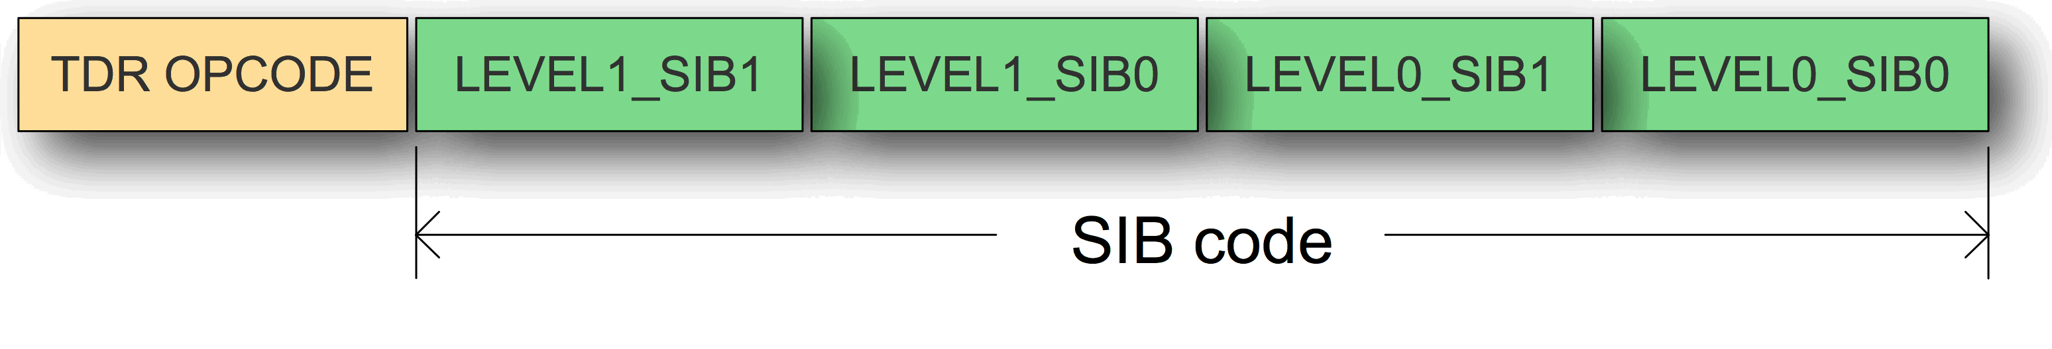
Figure 16. Address encode
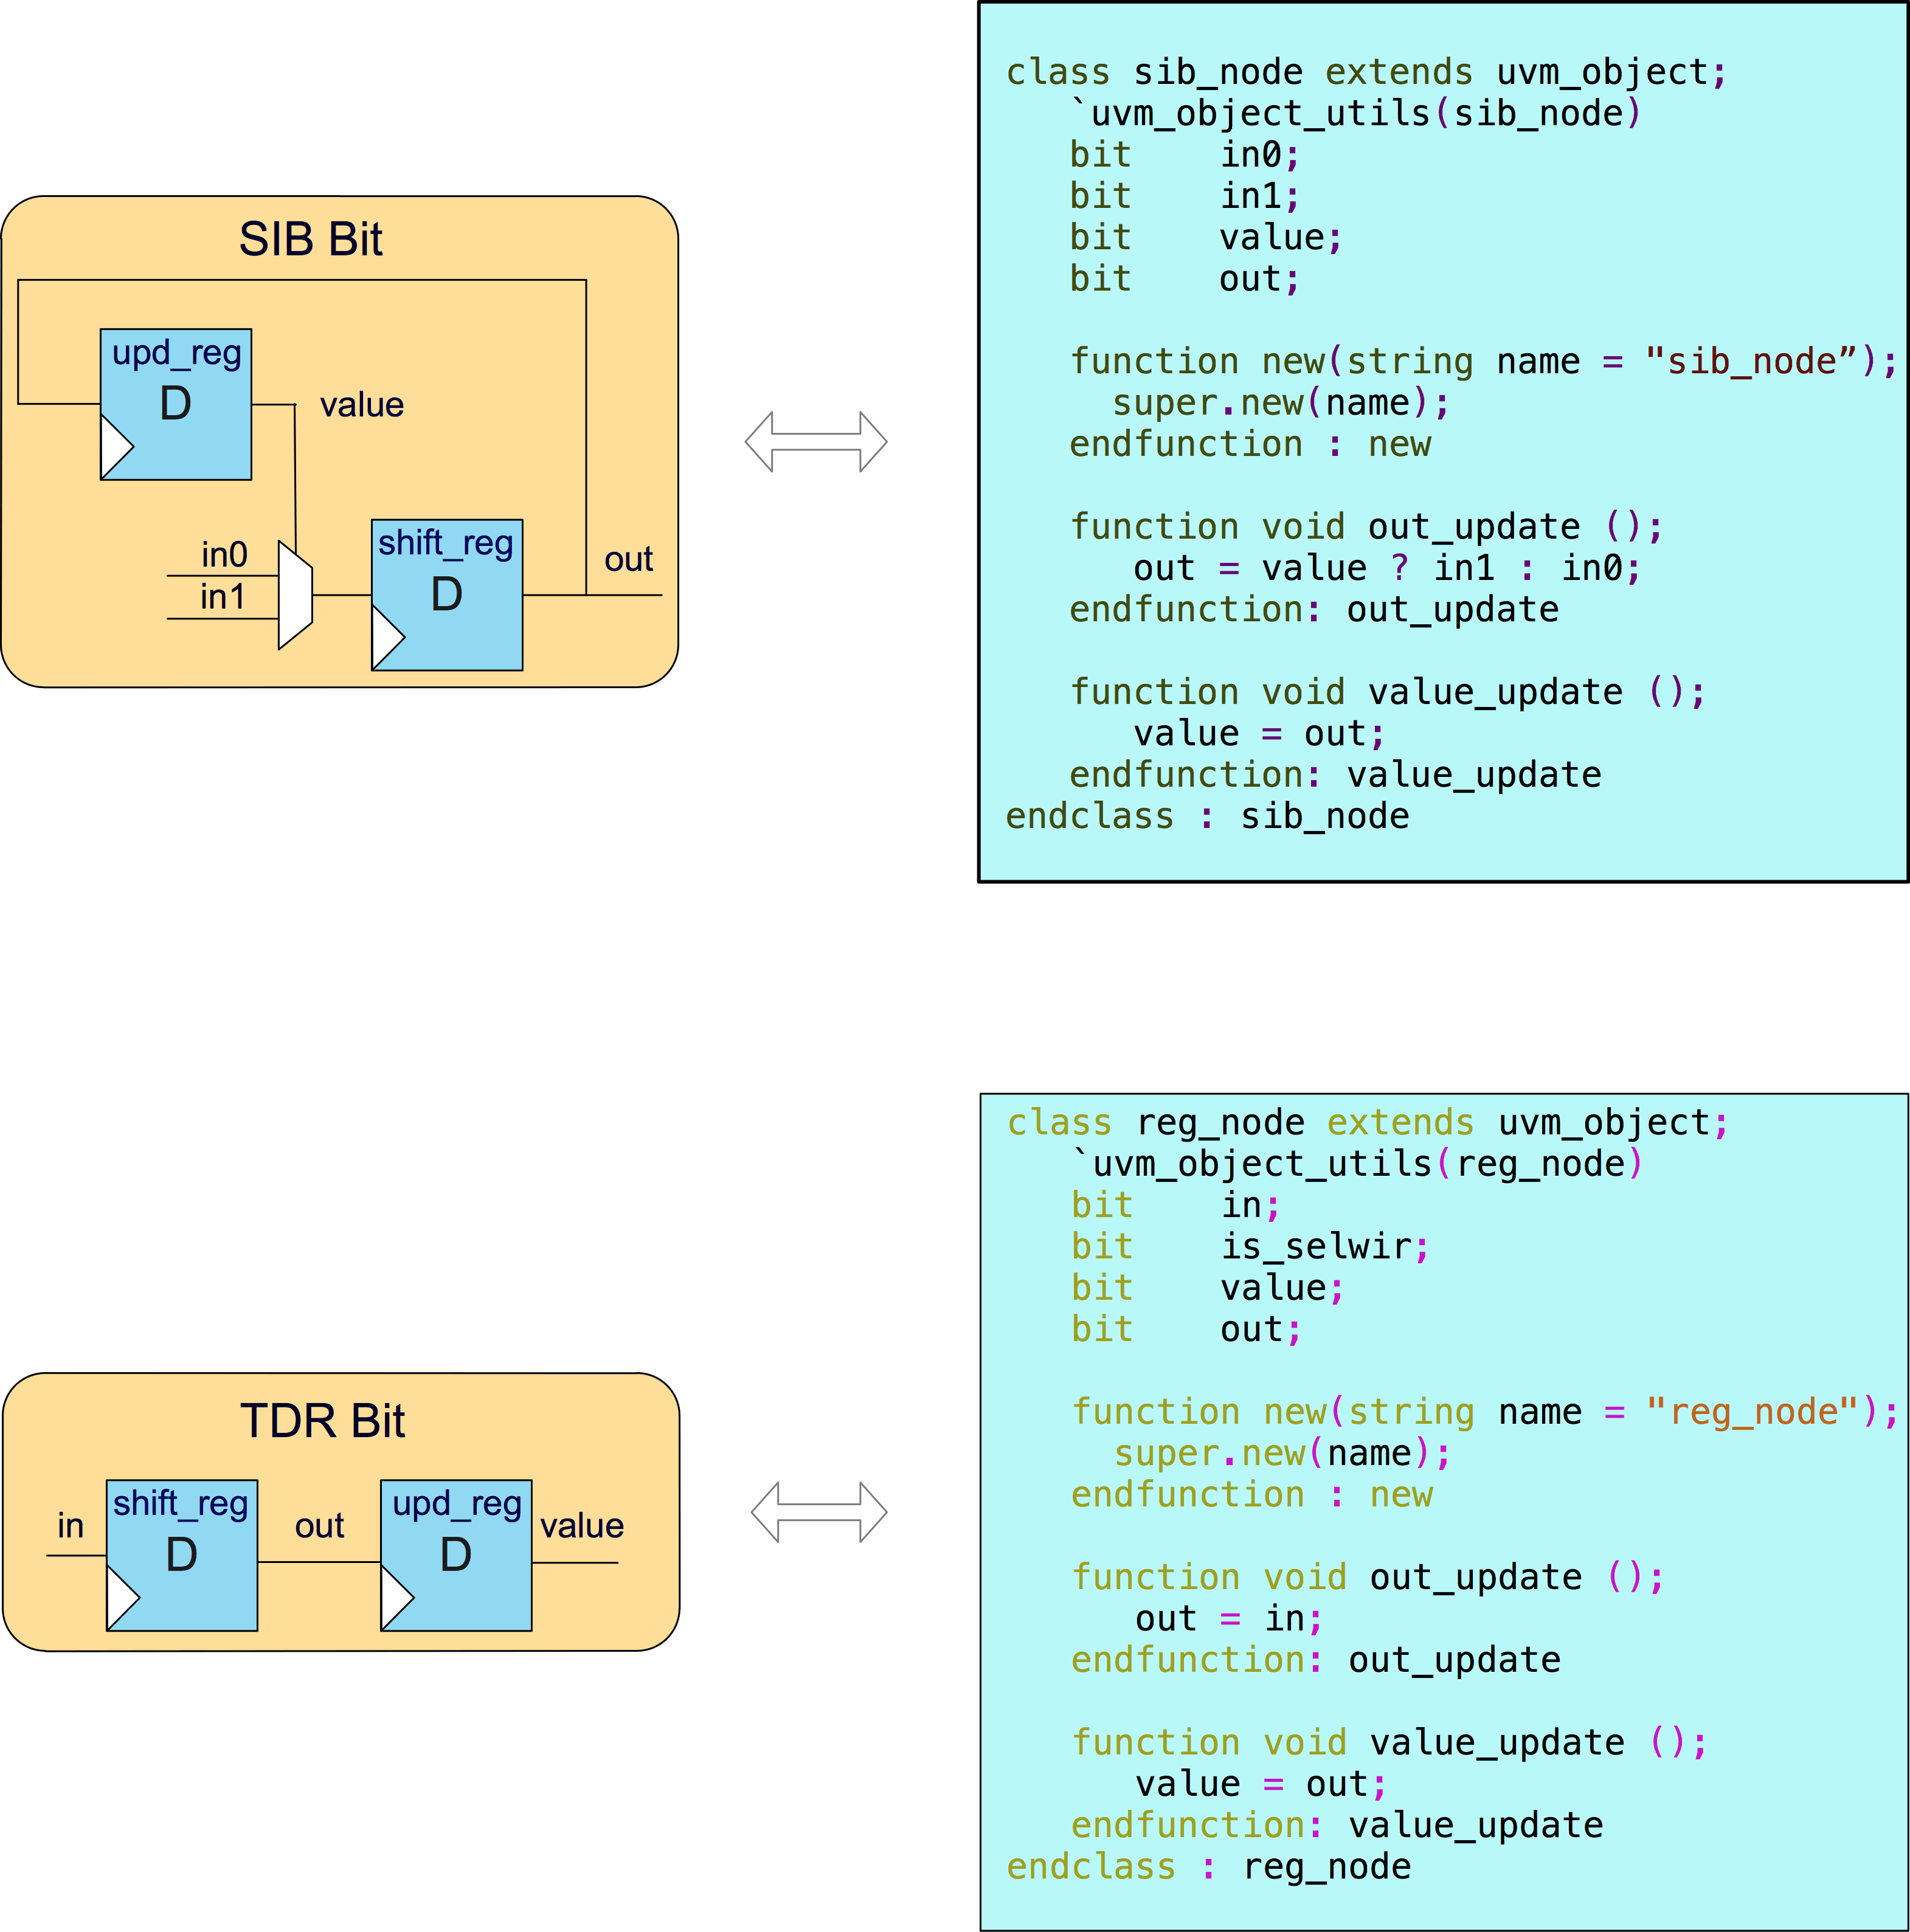
Figure 17. Network element model

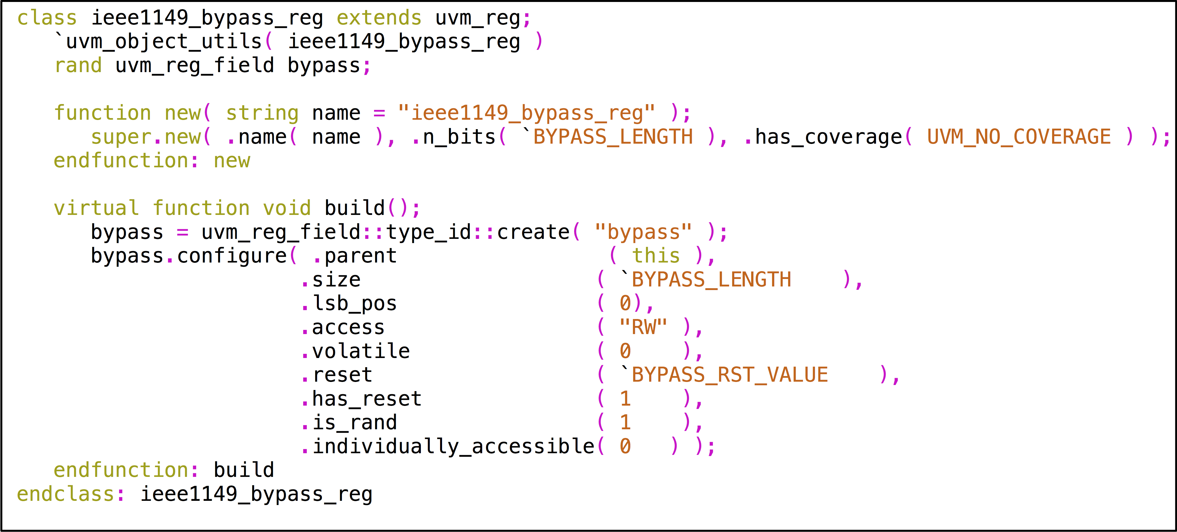
Figure 18. DFT TDR definition example

dft_tdr_transaction Class and bus_reg_ext Class
bus_reg_ext class is used for sending golden value to jtag_driver when doing register read or write in RAL. dft_tdr_adpter colons the extension information to the handle of extension in dft_tdr_transaction in bus2reg direction.
Fig. 19 and Fig. 20 shows all properties of dft_tdr_transaction and bus_reg_ext class.
read_not_write indicates current register operation is a UVM_READ or UVM_WRITE type.
address is the encoded TDR address.
If current register access kind is UVM_WRITE, dft_tdr_adapter shift write data to wr_data_q. If current register access kind is UVM_READ, dft_tdr_adapter shift the default of the register to wr_data_q.
extension is an object of bus_reg_ext class, which is used to transfer the side information for TDO pad checking in RAL.
reg_length stores current register’s length.
In bus2reg direction, if current register access kind is UVM_WRITE, dft_tdr_adapter returns data in wr_data_q else returns rd_data_q.
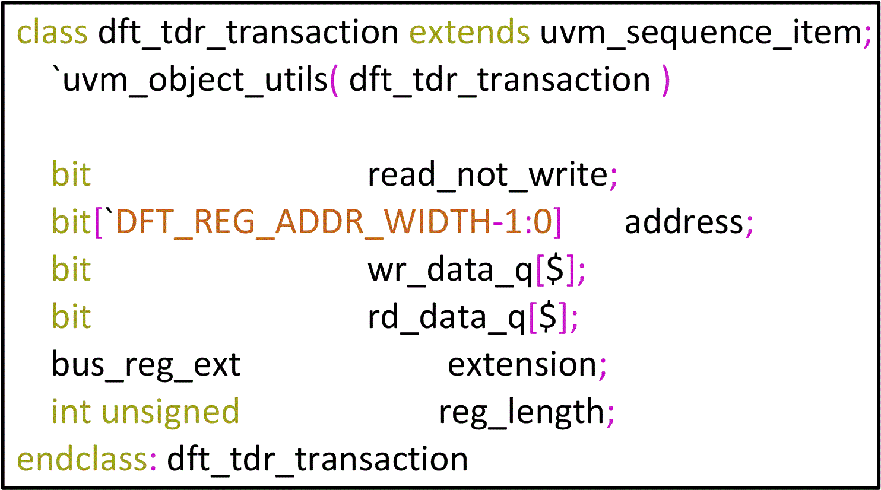
Figure 19. dft_tdr_transaction properties definition

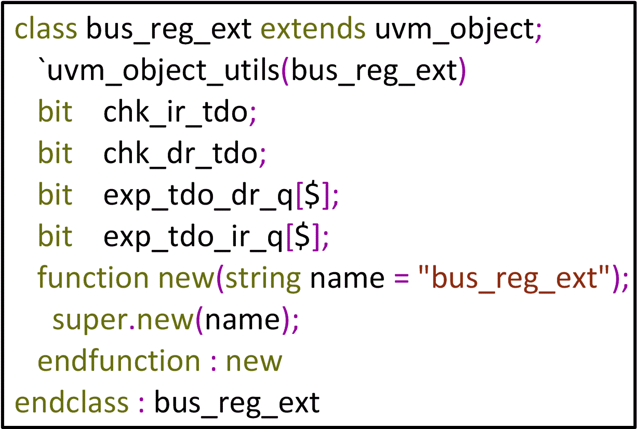
Figure 20. bus_reg_ext properties definition

IV. STIL Test Pattern Verification
In order to verify the content and behaviour of generated STIL file, we can use STIL VerifyTM to generate a Verilog test bench and re-run simulation before deliver to ATE test engineers.
STIL VerifyTM is a free verification utility provided by Mentor Graphics for checking the conformity of STIL files, which ensures that STIL files are syntactically correct, and features a Verilog test bench that allows Electronic Design Automation (EDA) and ATE tool developers to run and display STIL content in any Verilog simulator taking STIL file and DUT as input [3].

V. Discussion
In Figure1, pad_agent is mostly a physical layer agent though it group pads based on their interface protocols. If needed, users can implement an upper layer to convert protocol related transactions to pad_info_transactions and pass down to pad_agent.
This paper focuses on describing how to build a verification environment, which can convert UVM tests to test patterns for ATE test during simulation, so coverage collectors and scoreboards and are not show, users can easily implement them using transactions coming from jtag_monitor, dft_tdr_monitor and pad_monitor.
Since the generated STIL pattern is equivalent to its corresponding UVM test, a high quality test having high coverage decide a high quality test pattern.

VI. Conclusion
This DFT environment can be easily adopted in most projects for DFT function verification by overriding dft_env_configuration, grouping pads as show in Section 2.1 and defining related interfaces.
By modifying call_stil_gen () method in each driver to transfer pad toggle and measurement information to the format of other test language required, this environment could also generate other format patterns ATE need not just STIL format.
Using this method, it saves several man months or usually a team’s work for translating DFT function test to STIL patterns in a project and avoid errors introduced in this process to save turn around debug effort.
The approach to lift TDR in RAL is also a general way and can be apply in most projects by modelling related dft_tdr_network and overriding dft_tdr_trans_to_jtag_trans_sequence.
This UVM based DFT environment works correctly in an experiment project and the generated STIL test pattern files pass simulation using STIL VerifyTM, which indicated it could be apply in real projects.
The next step is to use this environment in real projects and validate it in post-silicon debug.

References
[1] Stuart Sutherland and Tom Fitzpatrick, UVM Rapid Adoption: A Practical Subset of UVM, Section 3.7.4, 21,
http://events.dvcon.org/events/proceedings.aspx?id=180-12
[2] Mentor Graphics, Online UVM Cookbook, Section Sequences/Layering, 302–307,
http://verificationacademy.com/cookbook
[3] Mentor Graphics, https://www.mentor.com/products/silicon-yield/getting_started_stil.

